# Completion Checklist (DELETE BEFORE POSTING)

* ~~Update <MONTH> and <YEAR> in header~~
* ~~Update V<X.Y.Z> in header~~
* ~~Update <DEVICE NAME> in header~~
* ~~Add logo to or remove the “Place Logo Here” textbox in header~~
* ~~Update <YEAR> in footer~~
* ~~Update <Author> in footer~~
* Update webpage link in footer
* ~~Complete Overview page~~
* Update Maker Checklist
  + Maker To Do List
    - Remove irrelevant steps
    - Add specific customization options (if necessary)
  + Items to Give to User
    - List components of the device and quantities needed
    - State that the parts need to be tested, if that is necessary
* Add tools to Tool List
* Add supplies to Supplies table
* Complete relevant parts of Customization Guide
* Remove irrelevant parts of Customization Guide
* Complete 3D Printing Guide
  + Complete summary
  + Complete settings
  + Complete post-processing instructions
  + Add images of quality prints
* Complete Assembly Guide
  + Add required components table
  + Add required tools
  + Add required PPE
  + Complete step-by-step instructions
* Complete Testing section (if necessary)
* Complete Troubleshooting section (if necessary)
* Remove any help text
* Update Table of Contents
* Delete Completion Checklist

For detailed instructions on completing the Maker Guide, please see the [OpenAT Documentation Guide](https://github.com/makersmakingchange/OpenAT-Template/blob/main/OpenAT_Template_Guide.pdf).

# Overview

This document contains the necessary information to build the Redwood Joystick, a robust analog USB joystick that can be used for digital access or adaptive gaming. The Maker Checklist outlines the required steps, including questions for the User. The Tool List contains a comprehensive list of tools and supplies required to complete the build. The 3D Printing Guide contains print settings and quantities for the 3d printed components. The Assembly Guide contains all the necessary steps to assemble and program the device. Finally, the Testing Guide contains a set of tests to confirm the Redwood Joystick works properly.

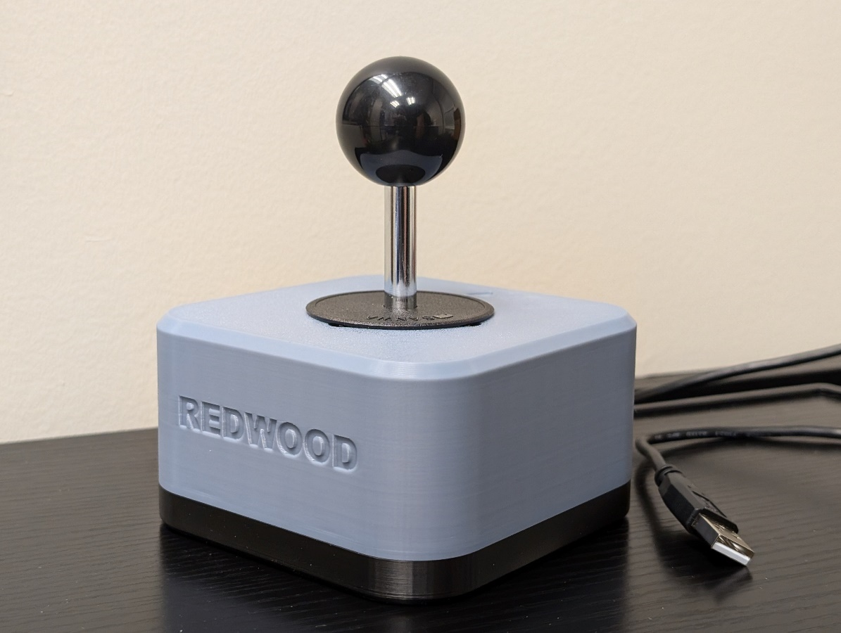

Contents

Overview 1

Maker Checklist 5

Maker To Do List 5

Items to Give to User 5

Tool List 6

Customization Guide 7

3D Printing Guide 8

3D Printing Summary 8

3D Printing Settings 8

Post-Processing 8

Examples of Quality Prints 8

Assembly Guide 10

Required Components **Error! Bookmark not defined.**

Required Tools **Error! Bookmark not defined.**

Required Personal Protective Equipment (PPE) **Error! Bookmark not defined.**

Assembly Instructions **Error! Bookmark not defined.**

Step 1 **Error! Bookmark not defined.**

Step 2 **Error! Bookmark not defined.**

Step 3 **Error! Bookmark not defined.**

Testing 10

# Maker Checklist

This list provides an overview of the steps required to build and deliver the Redwood Joystick

## Maker To Do List

* Read through the Maker Guide to become familiar with required components, tools, supplies, safety gear, and overall assembly steps.
* Talk to the User about customization options
  + Color of prints:
    - Can customize the top and/or bottom enclosure.
    - Topper colors can also be customized if toppers are requested.
  + Topper sizing:
    - The toper adapter allows the [Oak Toppers](https://github.com/makersmakingchange/Oak-Compact-Joystick/tree/main/Build_Files/3D_Printing_Files/Toppers) to be compatible. There is a default small, medium, and large size of toppers. There is also a [topper sizing guide](https://github.com/makersmakingchange/Oak-Compact-Joystick/blob/main/Documentation/Oak_Joystick_Topper_Guide.pdf) that you can send to the user to see which size and shape they would prefer.
  + Mounting options:
    - There are [RAM and ¼-20 mounting adapters available from the Oak joystick](https://github.com/makersmakingchange/Oak-Compact-Joystick/tree/main/Build_Files/3D_Printing_Files/Toppers) as well that will fit.
    - Ask the user which way they would like to mount the joystick.
      * Tabletop – ask if hook and loop should be added to the bottom
      * Mounting arm – ask if it has a ¼-20 thread or a RAM attachment (confirm it is RAM type B Compatible)
  + How they would like to receive the “User Guide” (PDF or physical copy)
* Order hardware components
* Gather tools, supplies, and safety equipment.
* Assemble the device
* Test the Redwood Joystick
* Print “User Guide” (if the User would like a physical copy)

## Items to Give to User

* Assembled Redwood Joystick
  + Optional:
    - Topper adapter if they want to use any Oak toppers.
    - Oak toppers they may want.
* User Guide

# Tool List

## Tools / Equipment

|  |  |  |  |
| --- | --- | --- | --- |
| Tool ID | Description | Required / Recommended | Notes |
| T01 | Philips screw driver | Required | Tighten/loosen Philips head fasteners |
| T02 | 3D printer | Required | Printing the enclosure/possible toppers and adapters |
| T03 | Canadian Small Coin (Dime) | Recommended | If using a topper adapter, it helps spin the adapter cover. Any small coin will work. |
| T04 | Flush Cutters | Recommended | Cutting the cable tie. Scissors or other cutting tools may work. |

## Supplies

|  |  |  |  |  |
| --- | --- | --- | --- | --- |
| Supplies ID | Description | Quantity | | Notes |
| S01 | Filament | 150g |  | |

## Personal Protective Equipment (PPE)

|  |  |  |
| --- | --- | --- |
| PPE ID | Description | Notes |
| P01 | Safety Glasses | When cutting the cable tie, wear safety glasses to prevent debris entering your eyes. |

# Customization Guide

The device can be printed in the user’s desired colour. As a suggestion, the bottom and top enclosure can be matching or different colors depending on the users preference.

# 3D Printing Guide

The device was originally printed on a Bambu P1S using the Bambu Studio slicer.

## 3D Printing Summary

|  |  |
| --- | --- |
| **Metrics** | **Single Unit** |
| Total Print Time (hour min) | 3h 2m |
| Total Number of Components | 2 |
| Typical Total Mass (g) | 139.01 |
| Typical Number of Print Setups | 1 |

## 3D Printing Settings

Note that the 3D printing material should be assumed to be PLA unless otherwise noted in the table below.

|  |  |  |  |  |  |  |  |
| --- | --- | --- | --- | --- | --- | --- | --- |
| **Print File Name** | **Qty** | **Total Print Time (hr:min)** | **Mass (g)** | **Infill (%)** | **Support(Y/N)** | **Layer Height/ Nozzle Diameter(mm)** | **Notes** |
| Redwood-Joystick-Enclosure-Base-v1.0 | 1 | 1:10 | 46.15 | 15 | N | 0.20/0.4 | **Print with 4 Wall Loops for increased strength** |
| Redwood-Joystick-Enclosure-Top-v1.0 | 1 | 1:58 | 92.84 | 15 | N | 0.20/0.4 | **Print with 4 Wall Loops for increased strength** |
| Redwood-Joystick-Topper-Adapter-Cover-v1.0 | 1 | 0:7 | 0.34 | 15 | N | 0.20/0.4 | **OPTIONAL** |
| Redwood-Joystick-Topper-Adapter-Nut-v1.0 | 1 | 0:19 | 4.87 | 15 | N | 0.20/0.4 | **OPTIONAL** |

## Post-Processing

Inspect the 3D printed parts for any printing defects, sharp edges, or burrs. Sharp edges and burrs can be removed with sanding or deburring tools. Examples of Quality Prints

Compare your 3D prints to the images here. If there are significant differences, you may need to reprint the part.

|  |  |
| --- | --- |
| Enclosure | |
| Redwood-Joystick-Enclosure-Base-v1.0 | **Redwood-Joystick-Enclosure-Top-v1.0** |
|  |  |

|  |  |
| --- | --- |
| Optional Topper Adapter | |
| Redwood-Joystick-Topper-Adapter-Nut-v1.0 | **Redwood-Joystick-Topper-Adapter-Cover-v1.0** |
|  |  |

# Maker Component List

|  |  |  |  |  |  |  |  |  |
| --- | --- | --- | --- | --- | --- | --- | --- | --- |
| Enclosure | | | | | | | | |
| A01 | Screw, #4 self-tapping 3/8" length | QTY: 4 | A02 | UltraStik 360 Joystick Component | QTY: 1 | A03 | Hex nut, M3 | QTY: 2 |
|  | | | (joystick component, dust cover, ball top, USB cable) | | |  | | |
| A04 | Cable tie, 4" | QTY: 1 | A05 | Enclosure Base | QTY: 1 | A06 | Enclosure Top | QTY: 1 |
|  | | |  | | |  | | |

|  |  |  |  |  |  |  |  |  |
| --- | --- | --- | --- | --- | --- | --- | --- | --- |
| *Optional: Topper and Mounting Adapters | | | | | | | | |
| B01 | Metric Hex Nut M6-1.00 | QTY: 1 | B02 | Topper Adapter Nut | QTY: 1 | B03 | Topper Adapter Cover | QTY: 1 |
|  | | |  | | |  | | |
| B04 | RAM Mounting Adapter | QTY: 1 | B05 | Camera Mount Adapter | QTY: 1 |
|  | | |  | | |

# Assembly Guide

|  |  |
| --- | --- |
| Assembly Section | |
| Part A: Enclosure |  |
| OPTIONAL: Part B: Topper/Mounting Adapters |  |

## Part A: Enclosure

### Part A: Required Components

|  |  |  |  |  |  |  |  |  |
| --- | --- | --- | --- | --- | --- | --- | --- | --- |
| Enclosure | | | | | | | | |
| A01 | Screw, #4 self-tapping 3/8" length | QTY: 4 | A02 | UltraStik 360 Joystick Component | QTY: 1 | A03 | Hex nut, M3 | QTY: 2 |
|  | | | (joystick component, dust cover, ball top, USB cable) | | |  | | |
| A04 | Cable tie, 4" | QTY: 1 | A05 | Enclosure Base | QTY: 1 | A06 | Enclosure Top | QTY: 1 |
|  | | |  | | |  | | |

### Part A: Required Tools and Supplies

* Philips Screw Driver
* 3D printer
* Flush cutters

### Part A: Required Personal Protective Equipment (PPE)

* Safety Glasses

### Part A: Enclosure Assembly Steps

#### Step A-01: Insert M3 Nuts

Take the enclosure base and locate the two nut catches. Take the 2 M3 hex nuts and insert them into these catches. It is recommended to line them up in the slot and then use the screwdriver to push the hex nuts inside the catches.

|  |  |
| --- | --- |
|  |  |
|  | |

#### Step A-02: Remove Mounting Plate from Ultrastik Joystick Component

Take the Ultrastik Joystick component and remove the 4 screws connecting the silver mounting plate to the rest of the joystick. **KEEP the 4 screws you removed in a safe place, you will need them for the next step**. You can disregard the mounting plate for the rest of the build.

|  |  |
| --- | --- |
|  |  |

#### Step A-03: Placing Joystick to Top Enclosure

Take the top enclosure and place the Ultrastik Joystick component inside with the USB port on the joystick component in the corner with the text on the inside of the top enclosure that says “USB GOES HERE”

|  |  |
| --- | --- |
|  |  |

#### Step A-04: Attaching Joystick to Top Enclosure

Take the 4 screws that you removed in Step 2 and insert them into the holes on the outer top of the top enclosure. Use the Philips Screwdriver to screw them through the top enclosure and into the Ultrastik Joystick component.

Make sure that the screws are sunken into the top of the housing. Approx 1 mm.

|  |  |
| --- | --- |
|  |  |
|  | |

#### Step A-05: Attaching the USB Cable

Take the USB cable and attach it to the USB port on the Ultrastik Joystick component. Take the cable tie and pass it through the strain relief feature and attach the USB cable to the side of it. Tighten down the cable tie and use the flush cutters to cut off the excess.

|  |  |
| --- | --- |
|  |  |
|  | |

#### Step A-06: Attaching the Bottom Enclosure

Take the bottom enclosure component and fit it to the top component with the cable exit lining up. Take the 4 #4 screws and screw them into the 4 holes on the bottom of the bottom enclosure. Tighten until snug.

|  |  |
| --- | --- |
|  |  |
|  | |

#### Step A-07: Add the Dust Cover and Ball Topper

Take the dust cover and ball topper from the Ultrastik and add them to the joystick. Place the dust cover on first and then thread on the ball topper.

|  |  |
| --- | --- |
|  |  |
|  | |

## Part B: Topper and Mounting Adapters

**This section is only needed if the user wants to use Oak Joystick toppers on with the Redwood or mount it on a ¼-20 camera mount or RAM (type B) mounting arm.**

### Part B: Required Components

|  |  |  |  |  |  |  |  |  |
| --- | --- | --- | --- | --- | --- | --- | --- | --- |
| B01 | Metric Hex Nut M6-1.00 | QTY: 1 | B02 | Topper Adapter Nut | QTY: 1 | B03 | Topper Adapter Cover | QTY: 1 |
|  | | |  | | |  | | |
| B04 | RAM Mounting Adapter | QTY: 1 | B05 | Camera Mount Adapter | QTY: 1 |
|  | | |  | | |

### Part B: Required Tools and Supplies

* Philips screw driver
* 3D printer
* **Optional:** Canadian small coin (dime)

### Part B: Required Personal Protective Equipment (PPE)

* None

### Part B: Topper/Mounting Adapter Assembly Steps

#### Step B -01: <Step Summary>

<Explain step simply in words. Make sure the image(s) of the step are on the same page as the text.>

<INSERT IMAGE OF STEP>

#### Step B -02: <Step Summary>

<Explain step simply in words. Make sure the image(s) of the step are on the same page as the text.>

<INSERT IMAGE OF STEP>

# Testing

<Explain any testing the maker will have to complete to make sure the device is working properly>

# Troubleshooting

<Include any common errors / issues the maker may encounter and suggestions how to solve them.>